**Django Learning**

**Step-1:**

1. (In command) - virtualenv project_env,
2. (In command) - project_env\scripts\activate
3. (In command) - pip install Django
4. django-admin startproject “Project Name(eg:silks)”
5. (cd to project) - python manage.py startapp “App Name(eg:mrag)”
6. To run the server, (cd to project) --- ‘python manage.py runserver’

**Step-2:**

Set-up VS-code as: 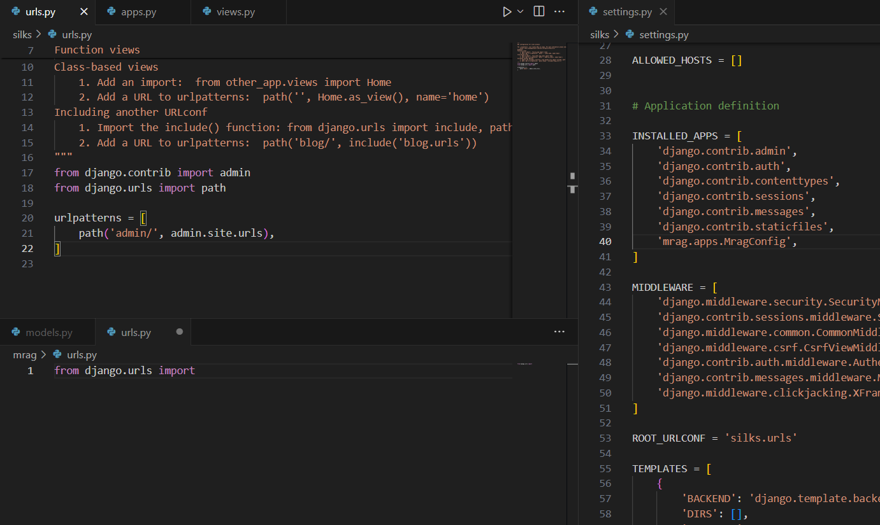

**Step-3:**

Create a file “urls.py” inside the app(mrag) folder and add these lines:

from django.urls import path

from . import views

urlpatterns = [

    path(" ", views , name = " " ),

]

And add these lines to urls inside “project(silks)” folder.

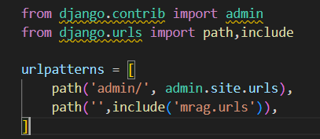

**Step-4:**

Add the “<app_name>.app.<app_name>Config” to “INSTALLED_APPS” list inside “Settings.py”,

Format : “<app_name>.app.<app_name>Config (last_line)

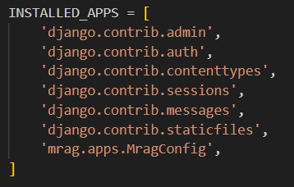

**HTML and CSS pages**

**Step-5:** (Adding HTML and CSS pages to the app)

Create a “templates” folder. And add its directory in “DIRS” list inside “settings.py”.

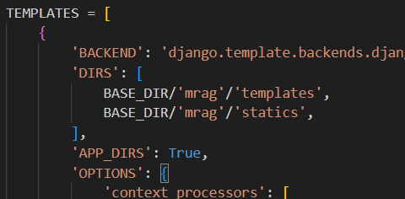

**Step-6:**

use “exclude” and “include” templates.

**Step-6b:**

Includes these in the app(marg) apps.py file.

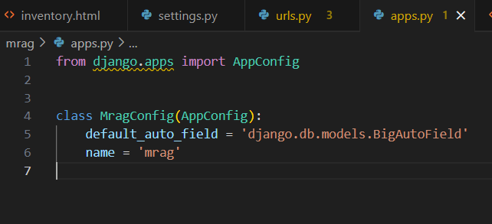

**Database**

**Step-7:**

Before creating models, u need to create superuser for admin permissions.

*python manage.py createsuperuser*

**Step-8: (Models)**

Create models class for everyTable.

class recipeName(models.Model):

id = models.UUIDField(primary_key=True, default=uuid.uuid4,editable=False)

    RecipeName = models.CharField(max_length = 30)

    Author = models.CharField(max_length = 30, null = True , blank = True)

    Desc = models.TextField(blank = True , null = True)

    #choices

    class CuisineChoices(models.TextChoices):

        INDIAN = 'Indian', 'Indian'

        AMERICAN = 'American', 'American'

        CHINESE = 'Chinese', 'Chinese'

        JAPANESE = 'Japanese', 'Japanese'

    Cuisine = models.CharField(max_length = 10,choices = CisineChoices.choices)

    def __str__(self):

        return self.RecipeName

Then, run *python manage.py makemigrations*

*python manage.py migrate*

**Step-9:**

Then, add this model class (recipeName) to the admin.py in ur app.

from . import models

admin.site.register(models.recipeName)

then add the data as ur wish to the database (recipeName).

**Step-10:**

Now, after this, come to views.py and try to get data from database and display in the static page.

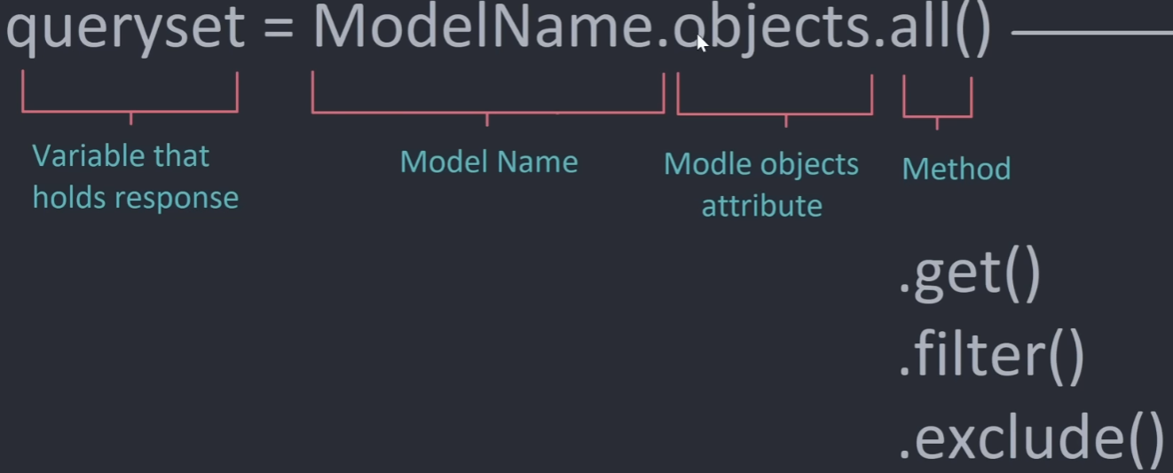

**Step-11:** (HTML page redirection & Fetching data from DB).

1. Once, the href is declared with href = {% url ‘*abc*’ id %},it redirects to url.py
2. Then, the ‘abc’ should only be refered in the name argument in the path function.
3. Also, the <str:xyz> , in the path function, should be mentioned in the views function “views.(fxn_name)” in views.py as xyz only.
4. Only the keys in the dictionary should be refered in the html page.

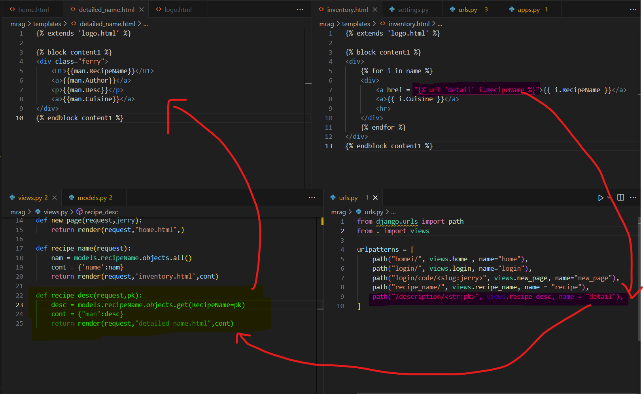

**Step-12:** (Posting Data).

1. Create a “forms.py” do necessary imports and import forms into “views.py”.

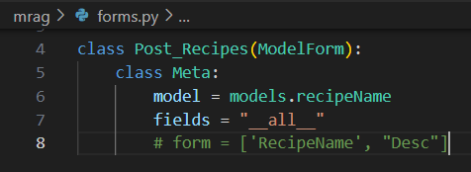

1. Then, create a new html file for posting into DB. (include csrf_token).

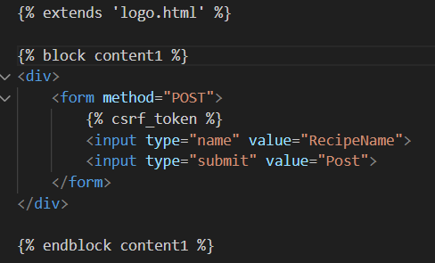

1. Inside forms.py, we do the updates to DB. The “recipe” in the redirect function denotes the name present path function in urls.py.

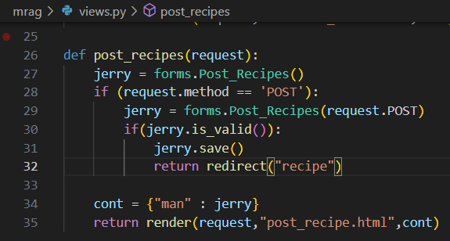

1. Inside urls.py, we need the path as

path("NewRecipes/", views.post_recipes, name = "create"),